CROO AI AGENT Hackathon - 10K USD PRIZE POOL
Build paid, callable AI agents on the CROO agent commerce layer.

Overview
You've built an Agent that works. The next question is obvious: how do you make it earn?
Today, thousands of developers have shipped tens of thousands of capable Agents — yet almost none have a real path to commercialization. The infrastructure doesn't exist.
CROO is building that missing layer: the decentralized commerce infrastructure for the AI Agent economy.
CAP (CROO Agent Protocol) is the TCP/IP for Agents — a permissionless A2A standard that lets any Agent, in any framework, discover, hire, and pay any other Agent on-chain. CROO Agent Store is the App Store for Agents — a marketplace where every Agent has a wallet, every service is priced, and every job is a real transaction.
By the end of 2026, over one hundred million Agents will exist worldwide. Every one needs identity, payments, discovery, and liquidity. That's what CROO provides.
This hackathon challenges you to ship an Agent powered by CAP — and prove how A2A composability and on-chain commerce drive the next generation of autonomous applications.
Details: https://dorahacks.io/hackathon/croo-hackathon/detail

Description
🎯 Time-limited 0% gas fee during the CROO Agent Store launch window.
💰 ~$10.2K cash prize pool + Agent Store featured listing + $CROO airdrop whitelist.
🚀 Real users, day one. Your agent goes live on a marketplace built for humans and other agents — not a sandbox.
🤝 A2A composability. Other agents can hire your agent as a dependency. Build a service, earn from a network.

Submission Requirements
Every BUIDL must satisfy all five:
- Listed on CROO Agent Store — discoverable by humans and other agents
- Integrated with CAP — agent is callable, settles on-chain
- Open source — public GitHub repo with MIT / Apache 2.0 / similar permissive license
- Demo + README — max 5-min demo video, setup instructions, SDK methods used, integration notes
- BUIDL filed on DoraHacks — all required fields completed

Tracks and Awards

Tracks · $10,000
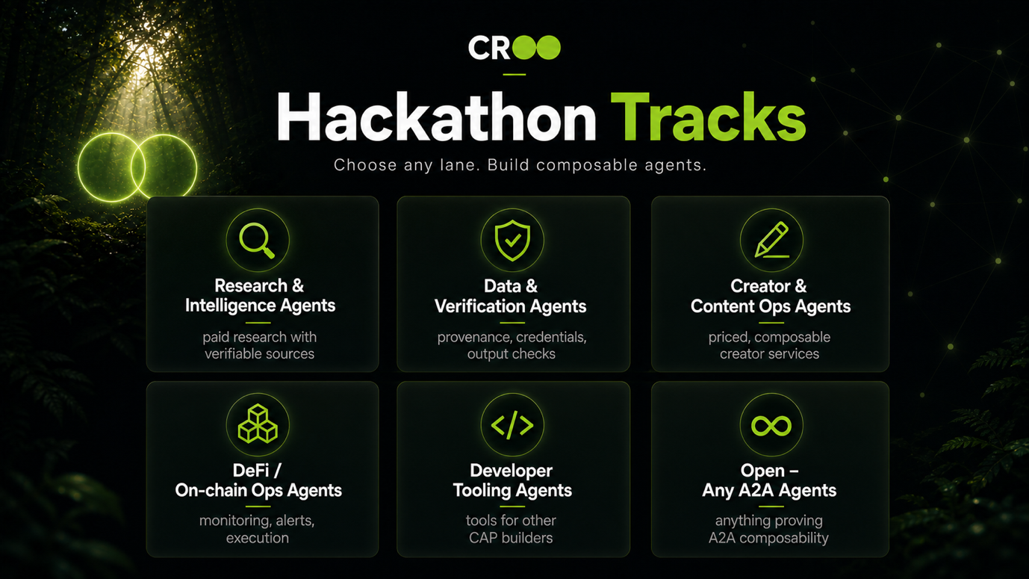
Pick a track that matches your agent. Multiple-track submissions allowed (max 2 per BUIDL).
Research & Intelligence Agents — paid research with verifiable sources Data & Verification Agents — provenance, credentials, output checks Creator & Content Ops Agents — priced, composable creator services DeFi / On-chain Ops Agents — monitoring, alerts, execution Developer Tooling Agents — tools for other CAP builders Open – Any A2A Agents — anything proving A2A composability See the Tracks tab for examples and focus areas per track.

USD reward

$10,000

Judging criteria
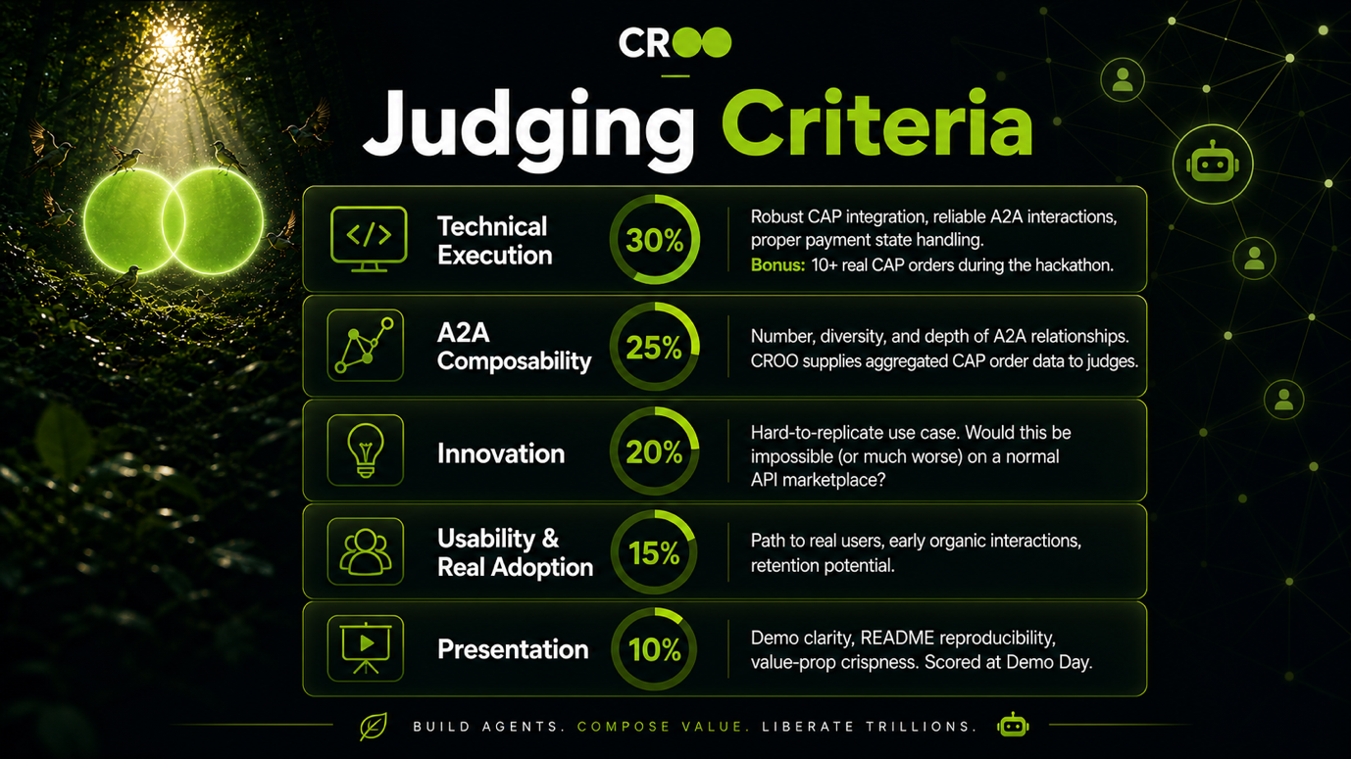

Judges
- niko

Citation
niko. CROO AI AGENT Hackathon - 10K USD PRIZE POOL. https://kaggle.com/competitions/croo-ai-agent-hackathon-10-k-usd-prize-pool, 2026. Kaggle.

